**DAILY ONLINE ACTIVITIES SUMMARY**

|  |  |  |  |  |  |  |  |
| --- | --- | --- | --- | --- | --- | --- | --- |
| **Date:** | **05/07/2020** | | | | **Name:** | **Syed Rabeya Aamir** | |
| **Sem & Sec** | **8th B** | | | | **USN:** | **4AL16CS112** | |
| Online Test Summary | | | | | | | |
| **Subject** | | **__** | | | | | |
| **Max. Marks** | | **__** | | **Score** | | **---** | |
| Certification Course Summary | | | | | | | |
| **Course** | **INTRODUCTION TO CYBER SECURITY.** | | | | | | |
| **Certificate Provider** | | | **Great Learning** | **Duration** | | | **5.5 hrs** |
| Coding Challenges | | | | | | | |
| **Problem Statement:**  **1)**  Python code to demonstrate checking of element existence using set() +  in +using sort() bisect_left() . | | | | | | | |
| **Status: Solved** | | | | | | | |
| **Uploaded the report in Github** | | | | **YES** | | | |
| **If yes Repository name** | | | | **rabeya** | | | |
| **Uploaded the report in slack** | | | | **YES** | | | |

**Certification Course Details:**

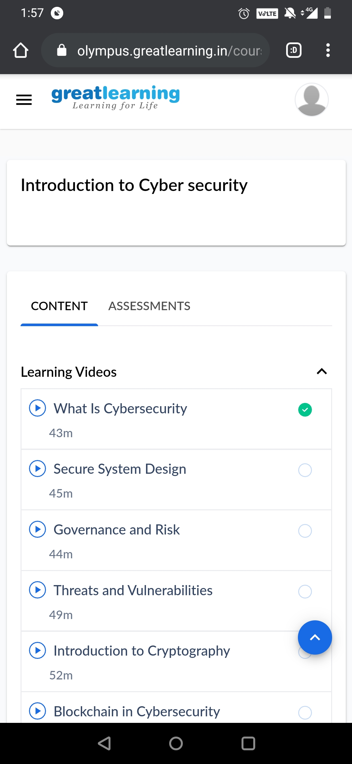

# CODE:

Program no:1

# Python code to demonstrate checking of element existence using set() +

in using sort() bisect_left() .

from bisect import bisect_left

# Initializing list

test_list_set = [ 1, 6, 3, 5, 3, 4 ]

test_list_bisect = [ 1, 6, 3, 5, 3, 4 ]

print("Checking if 4 exists in list ( using set() + in) : ")

# Checking if 4 exists in list

# using set() + in

test_list_set = set(test_list_set)

if 4 in test_list_set :

print ("Element Exists")

print("Checking if 4 exists in list ( using sort() + bisect_left() ) : ")

# Checking if 4 exists in list

# using sort() + bisect_left()

test_list_bisect.sort()

if bisect_left(test_list_bisect, 4):

print ("Element Exists")